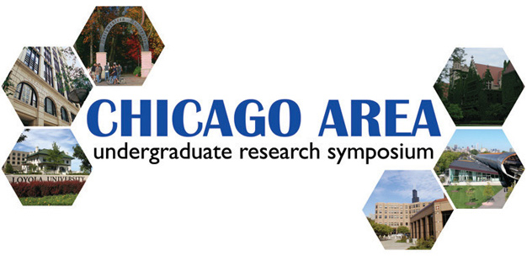

To CAURS Participants:

Thank you again for participating in the 3rd annual Chicago Area Undergraduate Research Symposium! This year’s event promises to be an exciting and informative one with extremely impressive research projects, distinguished guests, and faculty judges.

Here is the information you need to know:

Schedule updates:

Our schedule can be found on page 3. We will be serving a light breakfast for early arrivals during registration, but we advise you to grab a bite to eat before your arrival. The current weather forecast as of April 7 reports a 40% chance of rain so please do not forget to bring an umbrella! You will be traveling outside between buildings for poster and oral presentations.

Transportation:

We strongly encourage you to use public transportation. The Chicago El Stop (Red Line) is only one block away from the Loyola Water Tower Campus. The map of the Water Tower Campus can be found on page 4. However, at your own risk (the following information was taken from the Loyola website), you may be able to validate parking for the following garage if you arrive before 10 a.m.
Standard Parking
111 East Chestnut Garage
Chicago, IL. 60611
Phone: 312.640.1110 or 312.664.1198
1 hour or less | $15.00
2 hours or less | $20.00
3 hours or less | $22.00
3 hours to 10 hours | $25.00
10 hours to 24 hours | $31.00
Loyola Validations:
In by 10:00 a.m. & out by 7:00 p.m. | $11.00
In by 4:00 p.m. & out by 2:00 a.m. | $8.00
- Tickets must be validated at the desk in the lobby of 25 E. Pearson.
- All taxes are included in the price. All prices are subject to change.
Event details:

- You are strongly encouraged to walk around and look at your peers’ research projects.

- Oral presentations are split into three rooms. Please choose one room and stay there during the entire time. Please be attentive during oral presentations and feel free to ask questions.

- There will be a few graduate and medical school information tables during lunch. We encourage you to take a look around and ask questions to their admissions representatives. Your interest will also encourage them to return next year.

- Lunch will be served in the lower level of the Law Center on 25 E. Pearson. You are free to eat lunch there or visit local restaurants. Please be back by poster presentations.

- Dinner arrangements have been reserved according to your attendance as specified in your registration form. Participants not staying for the banquet are still encouraged to listen to the research lecture by Dr. Thomas Meade of Northwestern University, which will be held directly before and in the same hall as the banquet.

- You are strongly encouraged but need not to be present at the awards ceremony following the banquet to win an award. Awards will be given to the top poster presentation in each subject, the overall top poster presentation (Cribari President’s Award), top oral presentation, and top research proposal.

- Bring your own assembly materials! We will be providing easels, but you will need to bring your own thumbtacks or Velcro.

Above all, this event requires BUSINESS PROFESSIONAL ATTIRE.

Please email info@caurs.com or visit our website at www.caurs.com if you have any questions or concerns. Thank you and see you on April 14, 2007!

